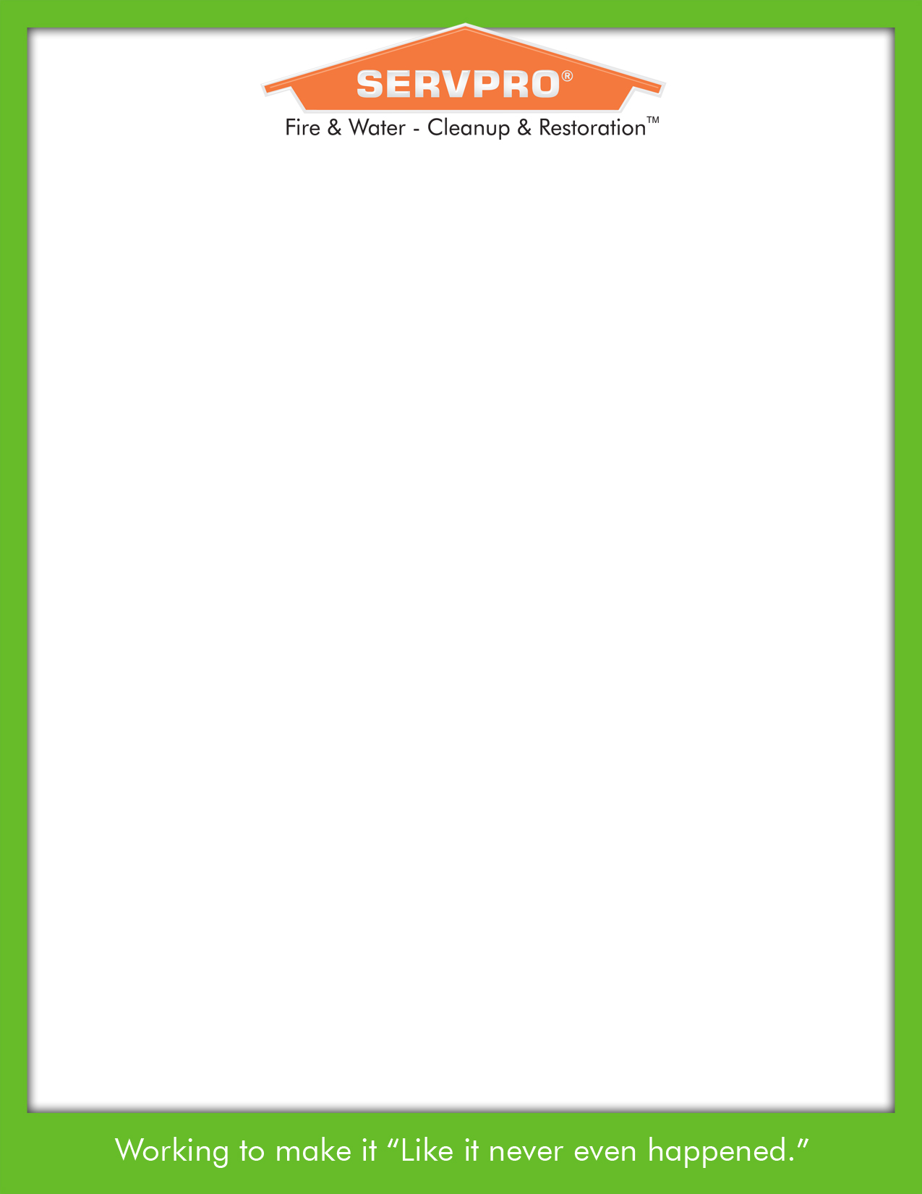
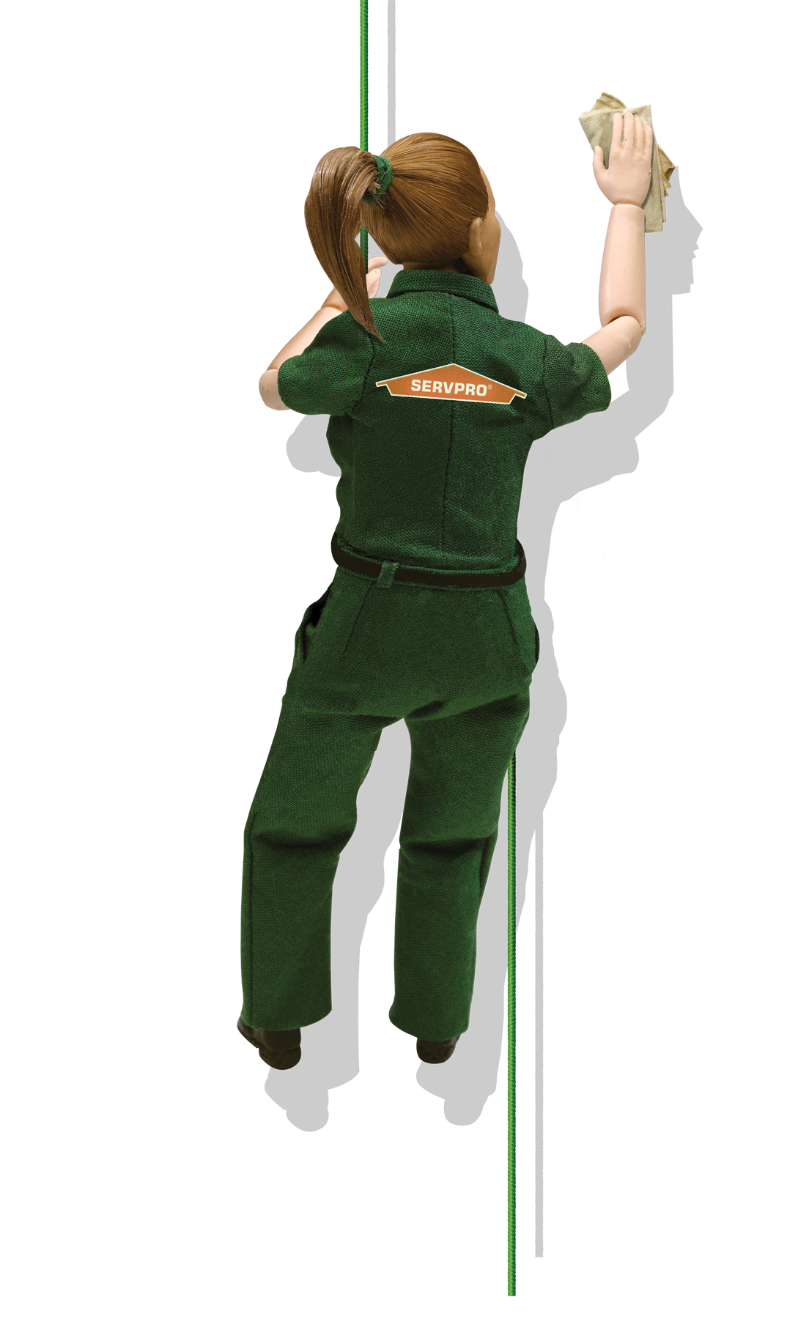
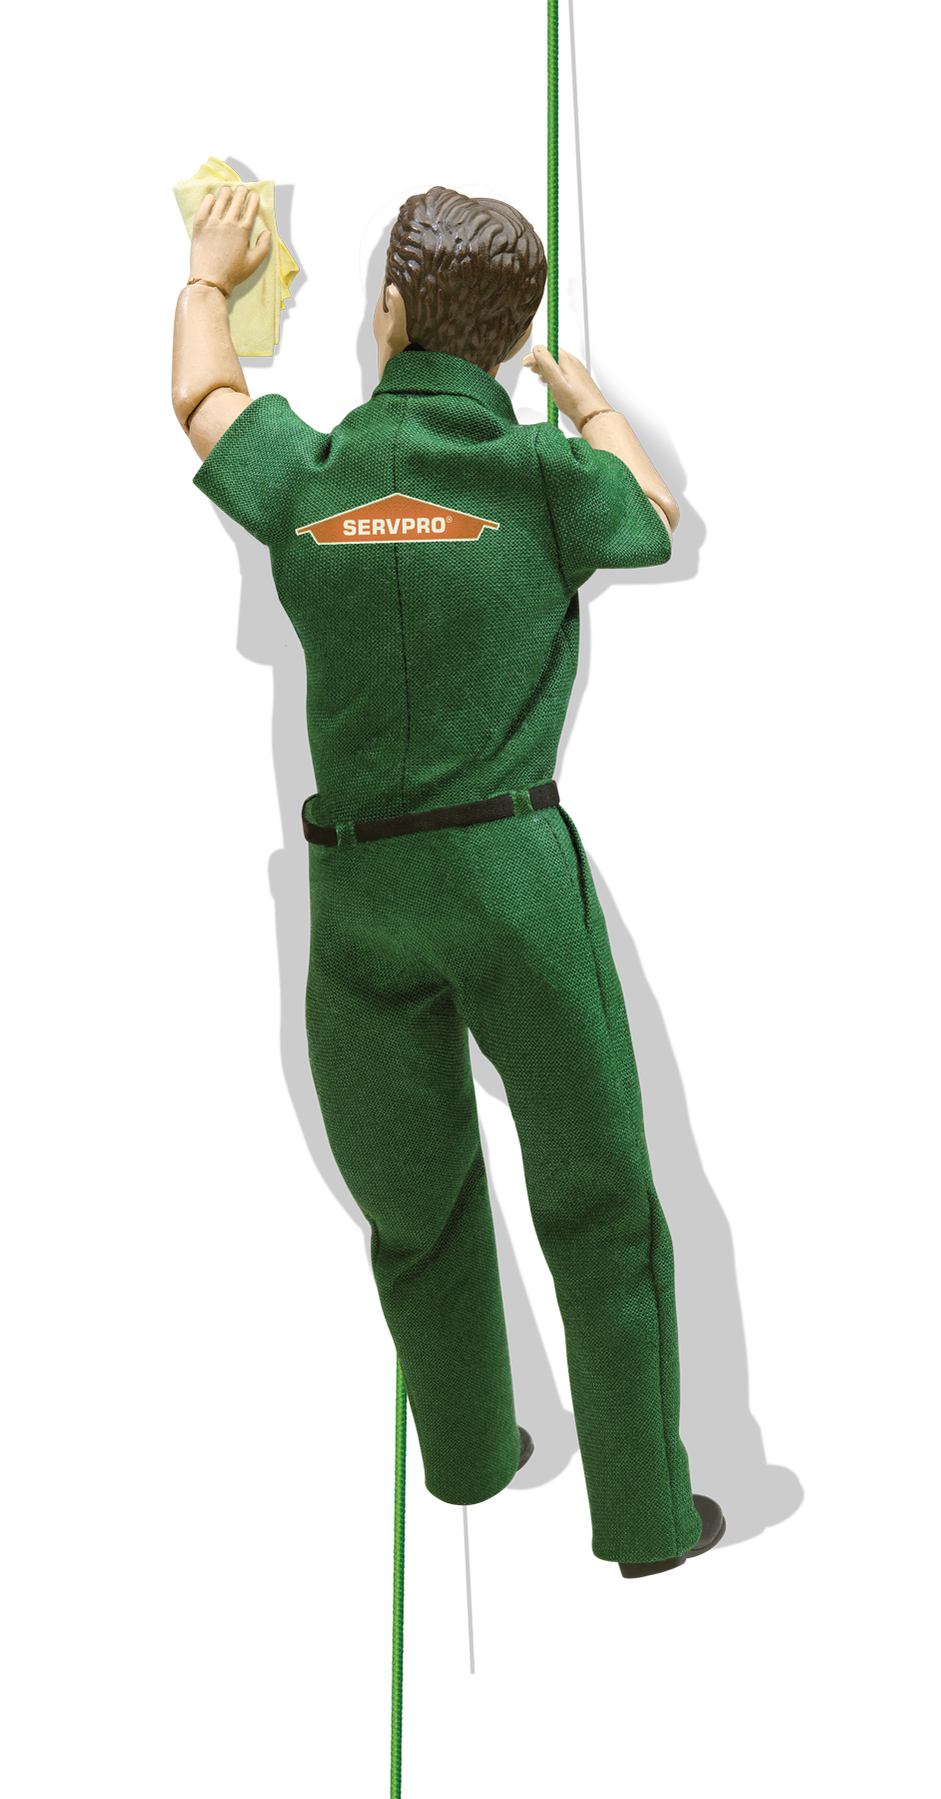

Servpro Industries, Inc. #10587
will be offering TWO Continuing Education Seminars on

Thursday, May 25th, 2017

CLASSES WILL BE HELD AT THE FOLLOWING LOCATION:

Fairfield Inn & Suites- Raleigh-Durham Airport Brier Creek
10040 Sellona Street
Raleigh, NC 27617

The subjects will be

ETHICS

3 INSURANCE Credit Hours

Course #
10183
Registration Time
8:30 am
Course Time
9:00 am
100% Attendance is REQUIRED in order to receive CE Credit for this course.
RESTORATIVE DRYING FOR WATER DAMAGE

2 INSURANCE Credit Hours
Course #
206198
Registration Time
1:30 pm
Course Time
2:00 pm
100% Attendance is
REQUIRED in order to receive CE Credit for this course.

and

$10.00 FEE (INCLUDES BREAKFAST, LUNCH, AND SNACKS)
Payable via PayPal at www.PayPal.me/SERVPRONorthRaleigh
Please Confirm # of Guests Attending
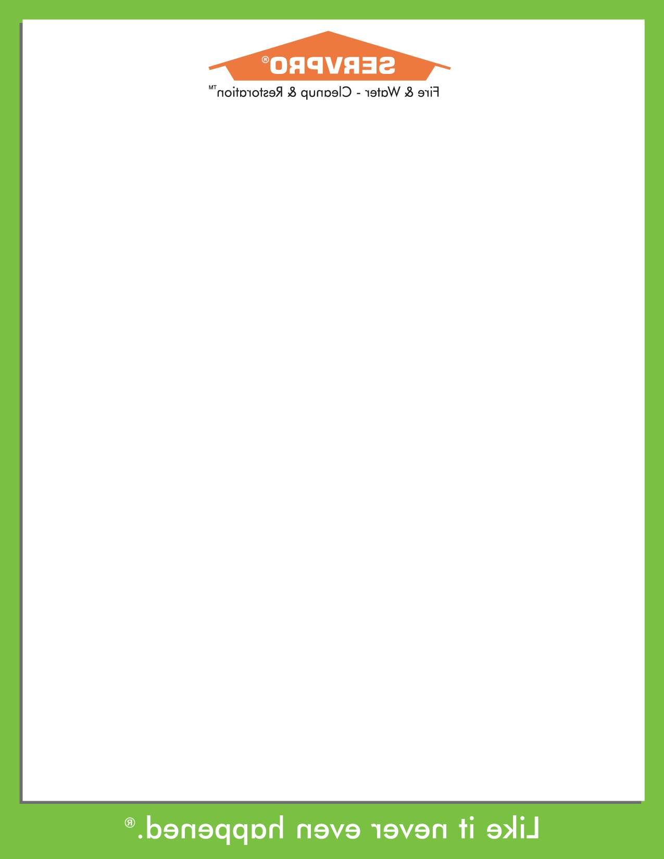

For reservations contact:

SERVPRO® of North Raleigh, Wake Forest, &

North Durham

phone (919) 790-1222, fax (919) 876-2279

Education@SERVPRO-rne.com

