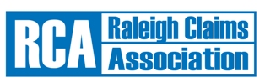
Continuing Education

Thursday April 17, 2014

Morning Session-9AM-12PM

 | Course Name/Number/CEU |  | Flood Insurance Seminar – Course Number C76646*
 | Presenter: |  | McAngus, Goudelock & Courie
Lunch 12PM-1PM.
Sponsored by:
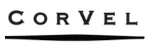
Afternoon Session 1PM-4PM
Course Name/Number/CEU: |  | Ethics for North Carolina Adjusters – Course Number 77620*
Presenter: |  | Teague, Campbell, Dennis & Gorham, LLP
*Per NC Administrative code, 11 NCAC 06A .0802 (e) “Licensees shall not receive ICECs for the same course more often than one time in any biennial compliance period.” Please be advised these same course numbers were offered at our April, 2012 CE class. If your compliance period has ended since then, you CAN take these classes once again for credit.

The CE class will be held at North Carolina Farm Bureau Headquarters:
5301 Glenwood Avenue, Raleigh, NC 27612

If you plan to attend, you must register by April 10th, 2014. Please complete the lower portion of this flyer and submit it to: RCA, P.O. Box 10183, Raleigh, NC 27605, or email form to ce@raleighclaims.org
Remember your National Producer Number for the class roster.
------------------------------------------------------------------------------------------------------------------------------------------------
Name:

Address: City/State/Zip:

Telephone: Email:

Company/Title:
I will attend both CE sessions | =OR= | I will only attend the AM session
 |  | I will only attend the PM session
Already a 2014 member NO FEE
OR
$15.00 payable to “Raleigh Claims Association.” This includes a 1-year membership to the Association with a completed Application form; you can find the Application online at www.raleighclaims.org

