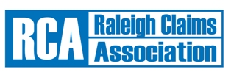
Continuing Education

Thursday September 22, 2016

Morning Session 9AM – 12PM

 | Course Name/Number/CEU |  | Consistency & detecting fraud in autos – 1 hr. – 75271
 |  |  | Technology in collision reconstruction – 1 hr. – 73132
 |  |  | Vehicle products failure – 1 hr. – 205488
 | Presenter: |  | Rimkus Consulting Group, Inc.
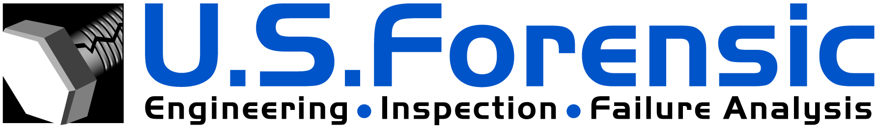 |  | Lunch 12PM-1PM sponsored by: Corvel  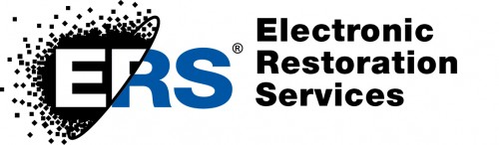  Afternoon Session 1PM-3PM
Course Name/Number/CEU: |  | Reducing electrical claims cost – 1 hr – 201238
Presenter: |  | Electronic Restoration Services (ERS)
Course Name/Number/CEU: |  | Asbestos awareness – 1 hr.
Presenter: |  | US Forensics, Rob Russo

The CE class will be held at North Carolina Farm Bureau Home Office Annex:
5301 Glenwood Avenue, Raleigh, NC 27612

If you plan to attend, you must register by SEPTEMBER 20, 2016
Please complete the lower l portion of this flyer and submit it to: RCA, P.O. Box 10183, Raleigh, NC 27605, or email form to ce@raleighclaims.org
Remember your National Producer Number for the class roster.
------------------------------------------------------------------------------------------------------------------------------------------------
Name:

Address: City/State/Zip:

Telephone: Email:

Company/Title:
I will attend both CE sessions | =OR= | I will only attend the AM session
 |  | I will only attend the PM session
Already a 2016 member NO FEE
OR
$10.00 payable to “Raleigh Claims Association.” This includes a 1-year membership to the Association with a completed Application form; you can find the Application |  |  | online at www.raleighclaims.org

